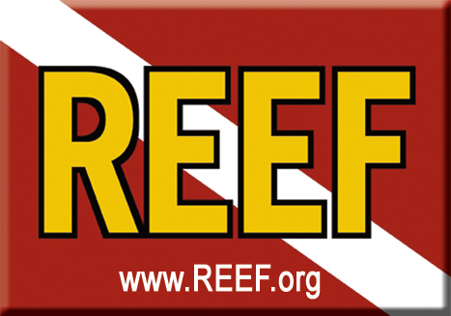

Reef Environmental Education Foundation

Conserving Marine Ecosystems by Enlisting Divers as Active Stewards and Citizen Scientists

Dear Friend, December 21, 2007

On Saturday, February 9, 2008, the Reef Environmental Education Foundation (REEF) will host its first annual “For the Love of the Sea” fundraising dinner at Amy Slate’s Amoray Dive Resort in Key Largo. Proceeds will support critical conservation projects that help preserve the Florida Keys coral reef ecosystem.

As a non-profit organization, REEF relies on the generosity of members and partners to support its programs. We are asking neighborhood businesses to support this event in two ways:

(1) Become an event sponsor and/or
(2) Donate items or services to a silent and live auction.

Event Sponsorship Levels

$1,000 = Queen angelfish  - Full page ad in program  - Logo on event banner  - Sign at bar indicating your support as “bar sponsor” | $500 = Nassau grouper  - 1/2 page ad in program  - Logo on event banner | $250 = Fairy basslet  - 1/4 page ad in program  - Placard indicating your support at one table
For sponsorship opportunities, please contact us by Friday, Jan. 25

Auction Item Donation
The silent auction will start at 5:00 pm. and close at 7:30 pm. The Live auction will start at 8:00pm. Please see reverse to donate items or services.

Tickets
Tickets may be purchased at Amoray Dive Resort. Contact Amy or Lea at 305-451-3595 or email to lea@amoray.com.

For questions please call Paula Mitchell at (305) 453-4799 or Sharon Hauk at (305) 451-2509.

Please visit www.REEF.org for more information about REEF. Thank you in advance for your support.

Sincerely,

Paula Mitchell and Sharon Hauk
REEF Events Committee

1st Annual For the Love of the Sea Event
Saturday, February 9, 2008
Amy Slate’s Amoray Dive Resort, Key Largo

Name/Company:

Event Sponsor Level ________________________________________________

I would like to donate for auctioned:
Service/Item*:
Value:
Description of item and Restrictions

Item enclosed/attached
Item requires pick-up
Item will be delivered ( to REEF HQ; to Amoray Dive Resort)

Contact Person:
Mailing Address:
City: State: Zip:
Phone: Fax:
Email:
Donor Signature:

*One sheet per item-please make copies of this form for additional items

All donors will receive an acknowledgment letter from REEF for tax purposes and be listed on the REEF website.

Please fax to 305-852-0301 by Friday, Feb. 1, 2008.

For questions please call Paula Mitchell at (305) 453-4799 or Sharon Hauk at (305) 451-2509.

